**2. a) x1=1, x2=0, x3=1, x4=1**

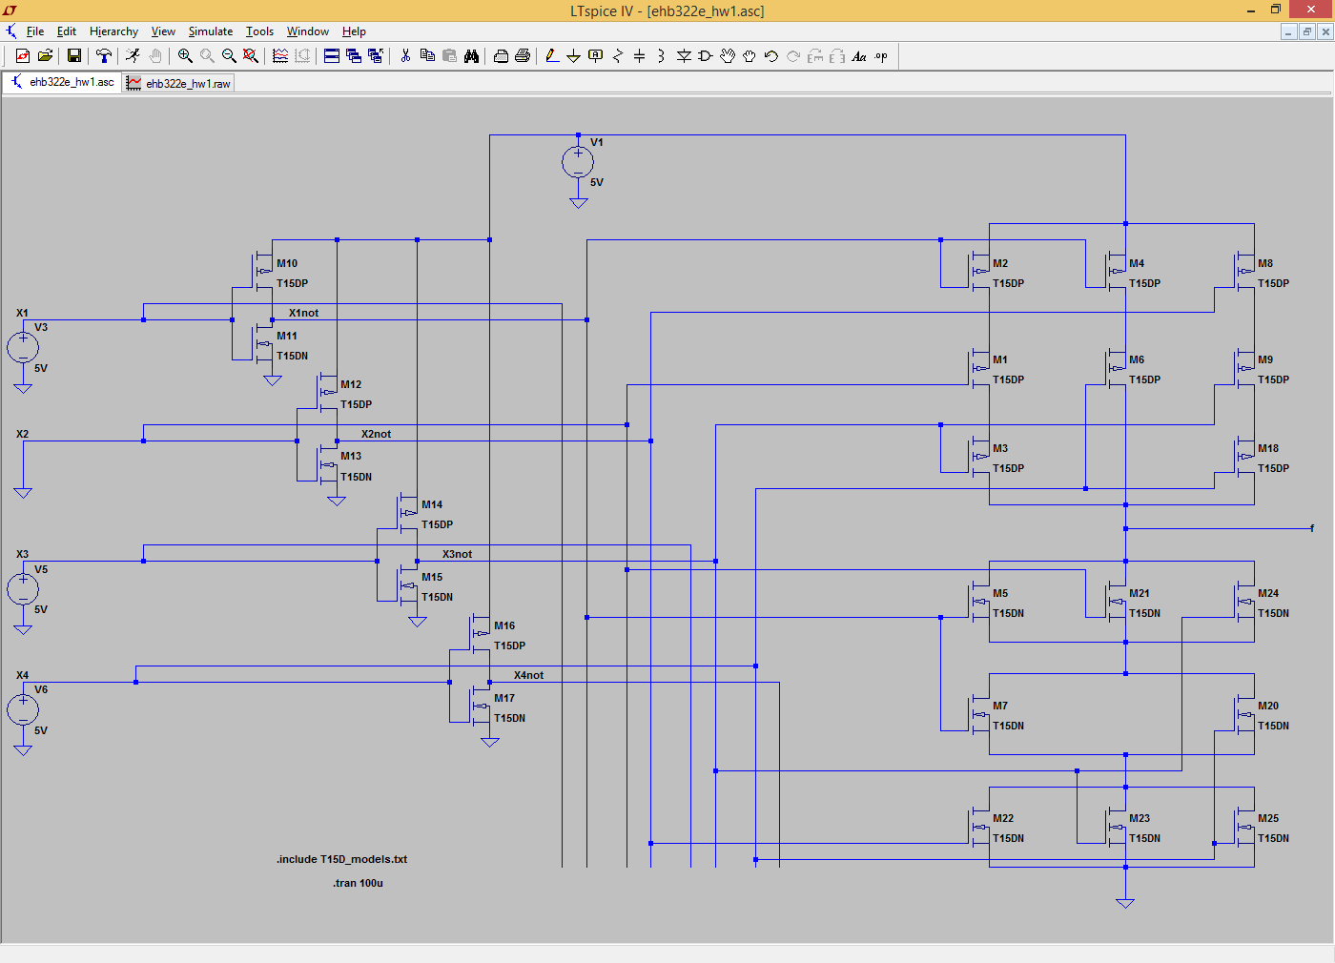

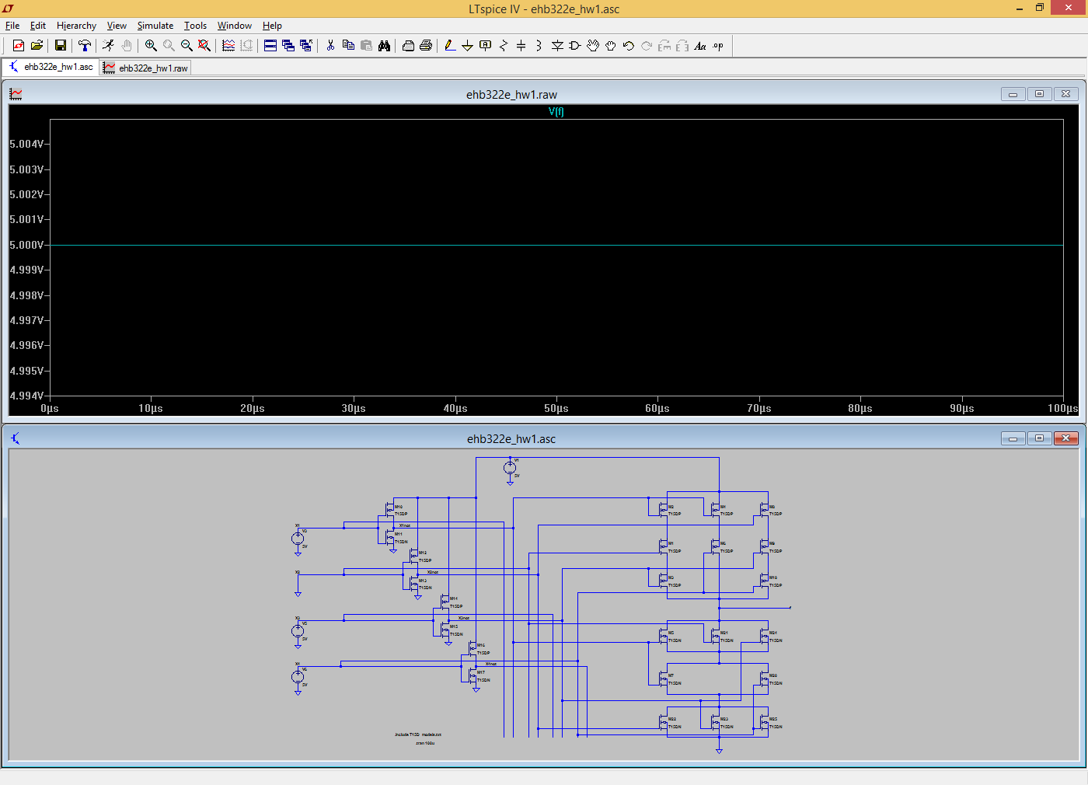

**2. a) x1=0, x2=1, 3=0, x4=1**

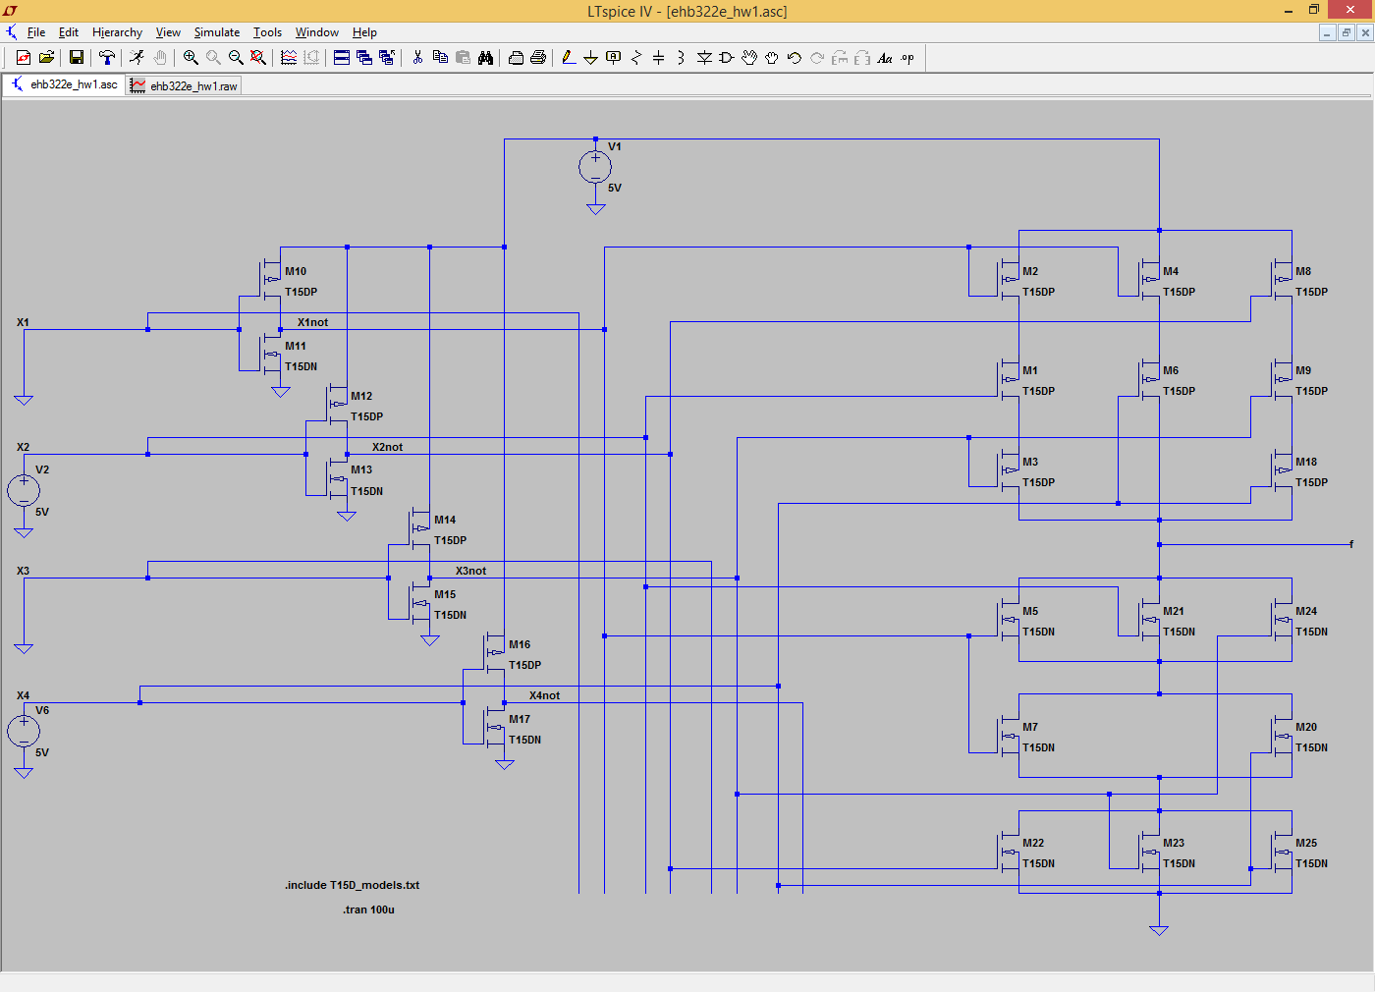

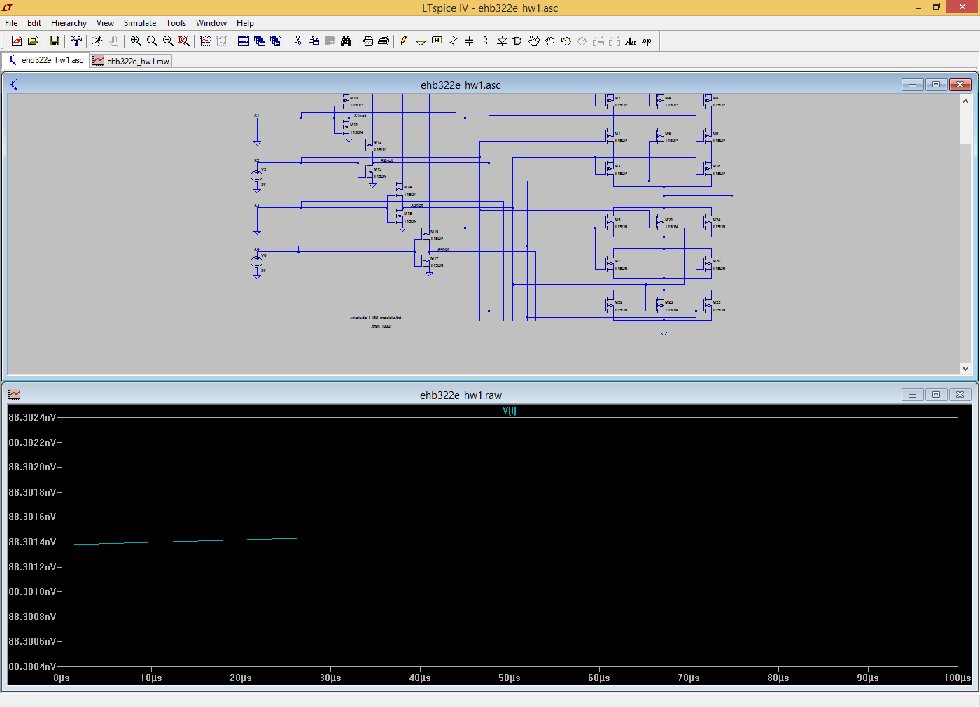

**2. b) W.C. tPLH; x1=1, x2=0, 3=0, x4=Pulse**

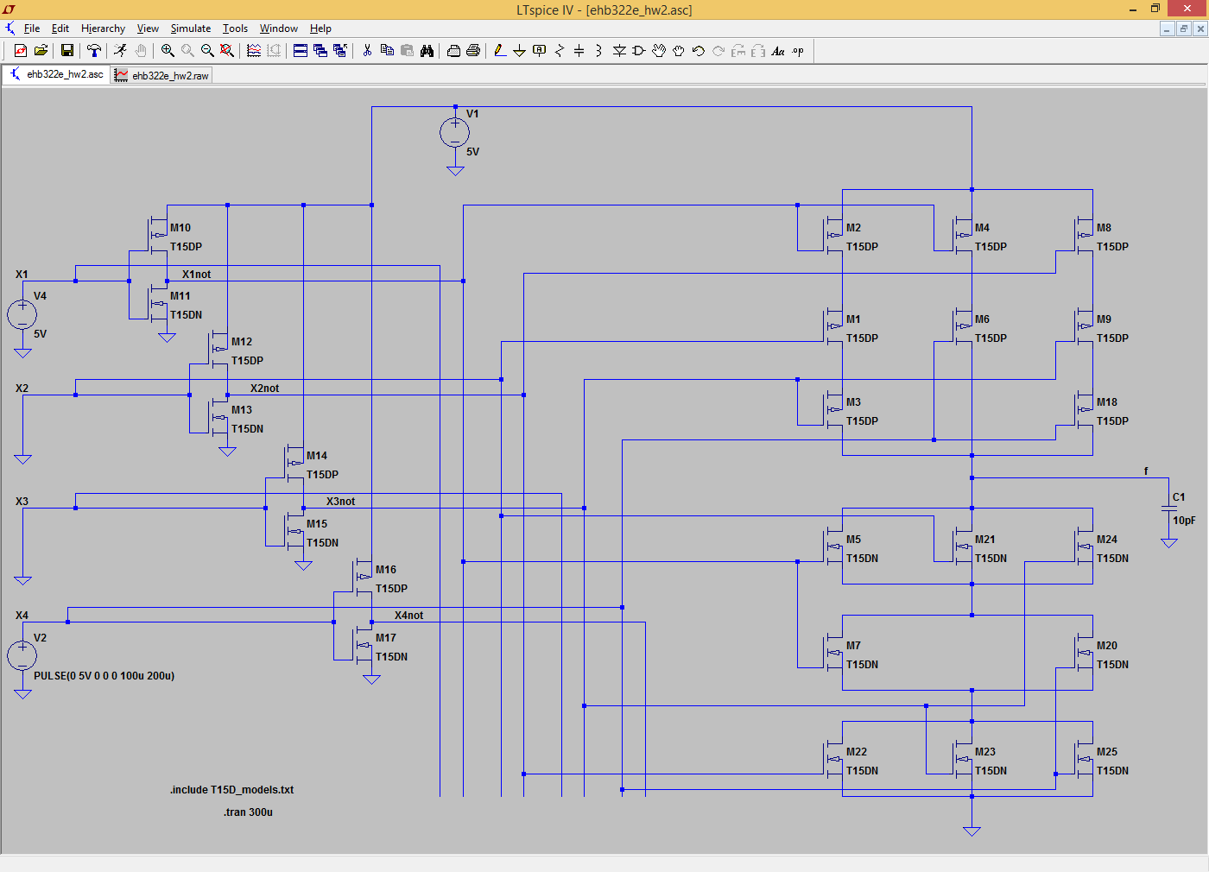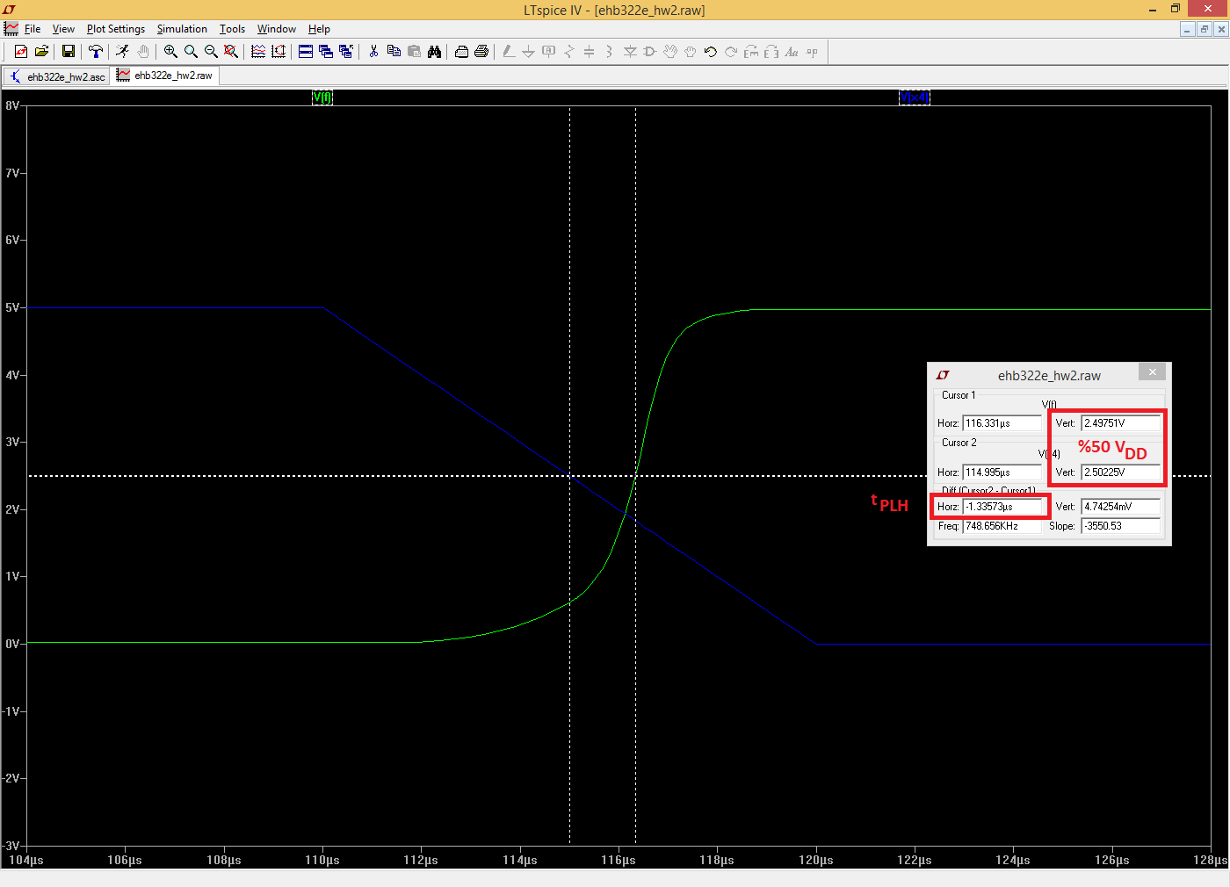

**2. b) W.C. tPHL; x1=1, x2=1, 3=1, x4=Pulse**

